TO: INTERESTED PARTIES
FROM: ROGERS FOR FLORIDA
RE: FL-02 SURVEY RESULTS
The Rogers for Florida campaign conducted a survey of 400 likely Republican primary voters in FL-02 from March 9-11, 2026. A majority of the interviews were conducted via cell phones, with additional interviews done via text to web and landline phones. The margin of error is +/-4.9% at a 95% confidence interval.

AUSTIN’S BEST MESSAGES
Austin’s best messages are the ones that present him in a conservative ideological light among the very conservative primary electorate in FL-02.

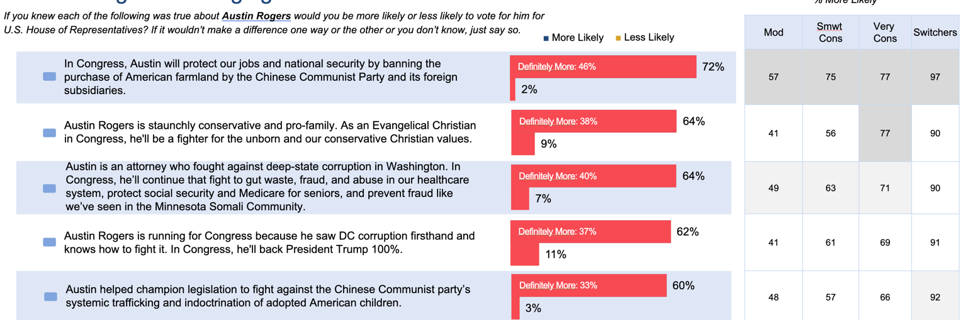

THE GROSS HITS
Keith Gross is unacceptable to the voters if they hear the right messages

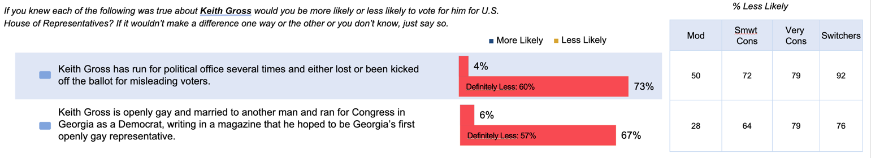
The messages hit even harder among self-identified evangelical voters (67% of all primary voters). The first message rises to 76% and the second rises to 73%.

STATE OF RACE
On TV, Voters in both media markets need to know that Austin Rogers is the only conservative in this race that voters can trust, rooted in faith, to fight with President Trump for the MAGA agenda. Voters should learn as much of this as possible by 5 weeks prior to the primary election, but need to see these messages through the duration of the campaign. This could contrast with “Democrat” Keith Gross attempting to buy this race to distract from his liberal past, but Austin’s bio is the priority. Voters also need to see a full suite of positive mail in this district.

